Temasek Polytechnic
School of Informatics and IT

Diploma in Information Technology (IT)

Project Plan

Project Particulars

Tutor | Miss Ho Li Chin
Class | P01
Project Title | Delonix Regia Hotel Management System

Project Team’s Particulars

Matric Number | Student Name
1405307H | Celine Neo Shi Ling
1401529A | Chen Yee Yin (Andrea)
1406183B | Ong Jing Hui Rachael
1402047C | Serena See Lee Ping

Contents
1. Introduction 3
a. Objectives and scope of the project 3
b. Assumptions and constraints 3
c. Definitions and acronyms 3
2. Roles and responsibilities 4
3. Estimates and project schedule 5
a. Work breakdown structure 5
b. Project Schedule 5
c. Budget Summary 5
4. Risk Management Plan 6

Project Plan

Introduction

Objectives and scope of the project
The objective is to develop hotel management system for Delonix Regia and add in personal information management system which is used in Sonium.

System should be able to handle reservations and payment, housekeeping, accounting. System should also be able to allow users to advertise deals, packages, and reserves rooms for large groups of guest.

Reservations can be made via online web booking or mobile booking; payment can be easily made by different payment methods. Guest details are also integrated into the hotel system, so whenever they pass an Identification card to scan in the system, the system would should past record of the guest and accommodate to them per their request.

Assumptions and constraints
Constraints are limitations imposed on the project. Limitations can include, resources, cost or schedule.

These are the concerns listed as the following:
- Inadequate resources to deliver the project on time
- Cost will increase due to lack of resources
- Inadequate resources available to complete the software
- Conflicting schedules of the members

Assumptions are anticipated events that might be accepted as true or as certain to happen, without proof.

These are the assumptions listed as the following:
- There are adequate skilled workers to complete the project
- There are adequate resources to ensure smooth project procedures
- Project is within budget

Definitions and acronyms
Acronyms | Definitions
SDLC | Software Development Life Cycle

Roles and responsibilities
Role & Responsibilities | Member
[Project Manager]  Analysis, Design, Testing, Maintenance | Chen Yee Yin (Andrea)
[Member]  Analysis, Implementation, Testing, Maintenance | Celine Neo Shi Ling
[Member]  Analysis, Implementation, Testing, Deployment | Ong Jing Hui Rachael
[Member]  Analysis, Design, Testing, Deployment | Serena See Lee Ping

[Analysis]

All members are included as this is an important aspect of the life cycle. It kick start the whole development phase. It is also important for the all members to be able to understand the customer’s requirement and brainstorm for the software

[Design]

Only Andrea & Serena are involved as they are more well versed in the designing aspect of the project

[Implementation]

Only Rachael & Celine are involved as they are more well versed in writing codes

[Testing]

All members including the project manager are involved as the testing phase is really important. With more people included, there can be a wider range of feedbacks and able to take note of more details to see if it meets the requirements and it is well designed. Plus there are quite an amount of things to be done for the testing phase, thus with more resources allocated to this phase, it will be able to finish soon

[Deployment]

Rachael knows the codes well enough as she was part of the developing team who wrote the codes for the software. Thus in any case if there is any hitch in the deployment phase, Rachael would be able to render her assistance. Serena is well equipped in documenting any documentations that is needed and is able to do installation of the software on each environment’s servers

[Maintenance]

As Andrea is the project manager, she is given the responsibility to maintain the software even after it is deployed so if there is any need for clarifications or enquiries, the stakeholders will still be able to have a point of contact who knows the software well enough. Celine is teamed with her as she was part of the developing team, thus she would know the software well enough too. In any case where Andrea needs help with the codes, she would be able to help.

All members are involved in every aspect, just that the listed members are in charge of the that certain aspects.

Estimates and project schedule

Work breakdown structure
- Initial Analysis
    - Kick off meeting
      - Plan Interview with Clients & Stakeholders
      - Conduct Interview with Clients & Stakeholder
      - Understand Client’s requirements
      - Identify Business Problem
    - Develop Project Plan
      - Define the scope and objectives
      - Define assumptions and constraints
      - Define Roles & Responsibility
      - Create a WBS
      - Create a Project Schedule
      - Create a Budget Summary
      - Create a Risk Management Plan
    - Create Terms of Reference
      - Define Introduction
      - Define the scope and objectives
      - Define distribution of workload
      - Define constraints of project
      - Define Resources
      - Define Product Positioning in the Market
      - Define Approach and Methodology
- Iteration 1
    - Analysis Objectives
    - Staff Interface
      - Design Staff Interface
      - Develop Staff Interface
      - Integrate & Test
    - Customer Interface
      - Design Customer Interface
      - Develop Customer Interface
      - Integrate & test
    - Demo Release
    - Client Feedback
    - Make Changes
    - System Testing
- Iteration 2
    - Analysis Objectives
    - Reservation Interface
      - Design Reservation Interface
      - Develop Reservation Interface
      - Integrate & Test
    - Payment Module
      - Design Payment Module
      - Develop Payment Module
      - Integrate & test
    - Demo Release
    - Client Feedback
    - Make Changes
    - System Testing
- Iteration 3
    - Analysis Objectives
    - Report Generation
      - Design Report Interface
      - Develop Report Generation Interface
      - Integrate & Test
    - Demo Release
    - Client Feedback
    - Make Changes
    - System Testing
- Maintenance

Project Schedule

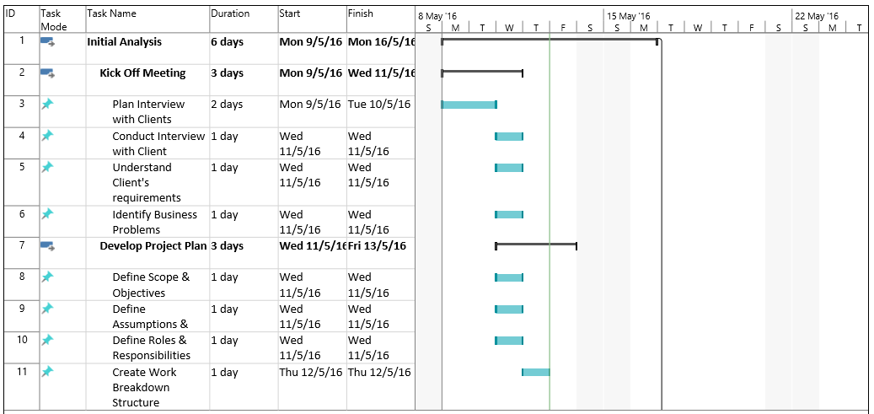

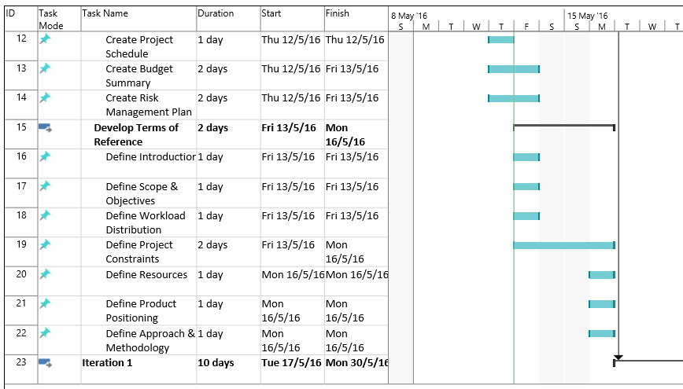

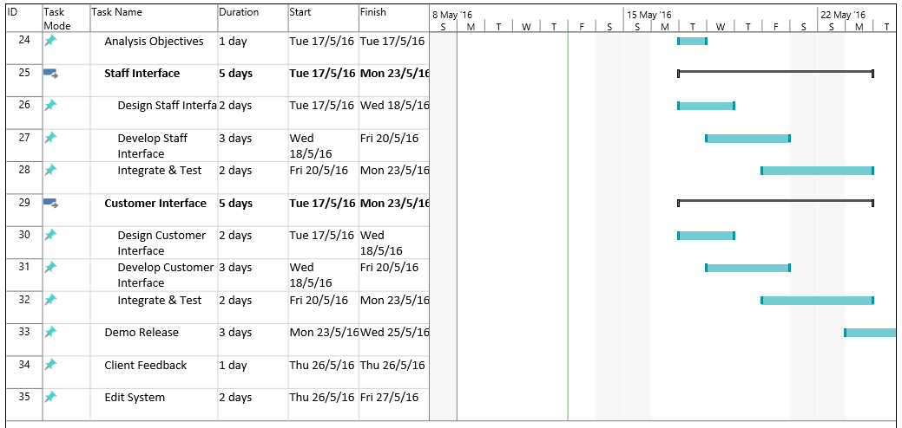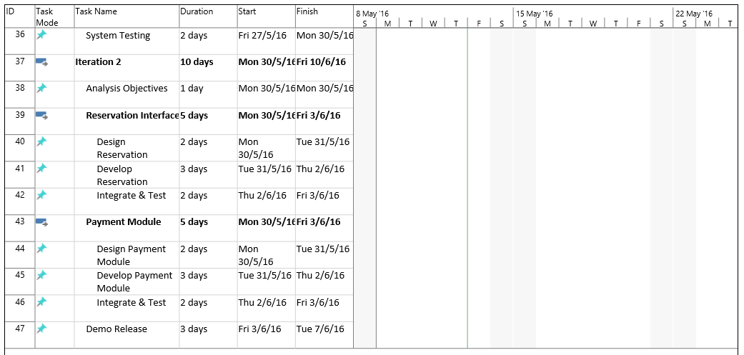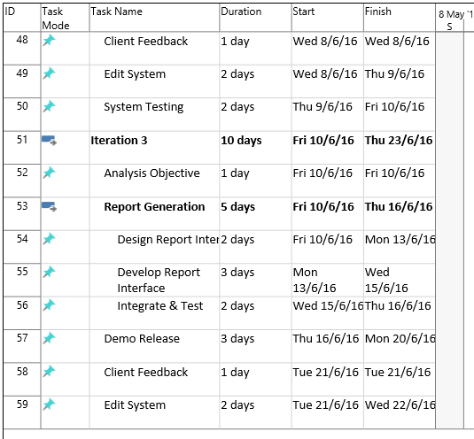

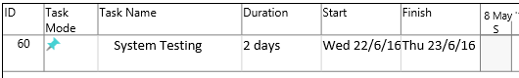

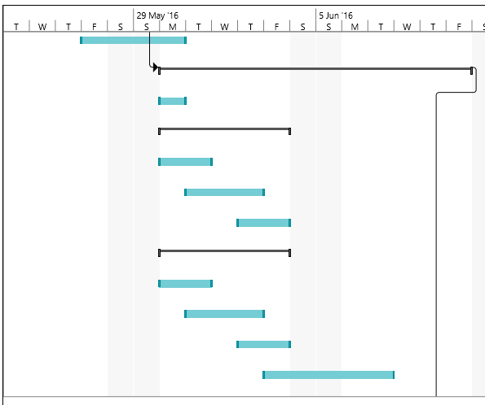

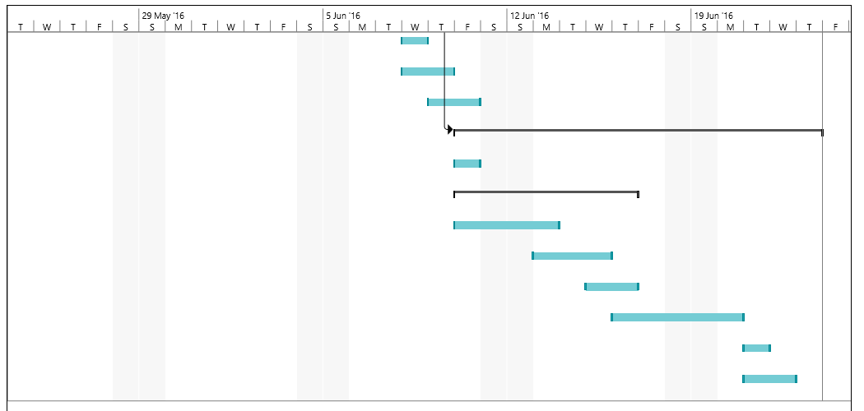

Budget Summary
Cloud Storage (elastichosts) – $154/month (12month prepaid - $1848)

Acer AZ3- 715 - UR61 – USD $749.99
= SGD $1029.79

Human Resource –2 Testers – $7/h, office hours (9am-5pm)
$56/day
$392/week
x2 testers = $784

Total: $1848 + $1029.79 + $784 = $3661.79

Risk Management Plan
 | Impact | Vulnerabilities | Strategy
Estimation and Scheduling | - Reliability of estimation and schedule | - Intangible nature and uniqueness of software | - Developers to have heavy involvement in the planning and estimating phases.
Requirement Inflation | - Threatens initial estimates  - Delay/derailment of project | - Emergent of new requirements that were not recognized in the initial stages of requirement gathering. | - Always keep client and developers in the loop. Both parties should be informed of the project’s progress from time to time.
Employee Turnover | - Delay/derailment of project | - Abandonment of project by one or more developers.  - Critical or vital information remain in the knowledge of developer(s) who choose to leave. | - Developers to collaborate closely with one another. Resources and knowledge to be shared generously.
Specification Breakdown | - Conflicting assumptions or decisions are made, affecting the project’s progress drastically | - Specifications may be incomplete.  - Specifications may conflict.  - Specifications may not be thoroughly understood by developers. | - Assign a Product Manager responsible of making critical trade off decisions.
Productivity | - Delay/derailment of project | - Unnecessarily long timelines. Developing team may lose their sense of urgency to work in earnest. | - Split work into short iterations.
Procedure | - Day-to-day operational activities might be hampered | - Conflicting priorities  - Improper process implementation | - Clarify responsibilities

